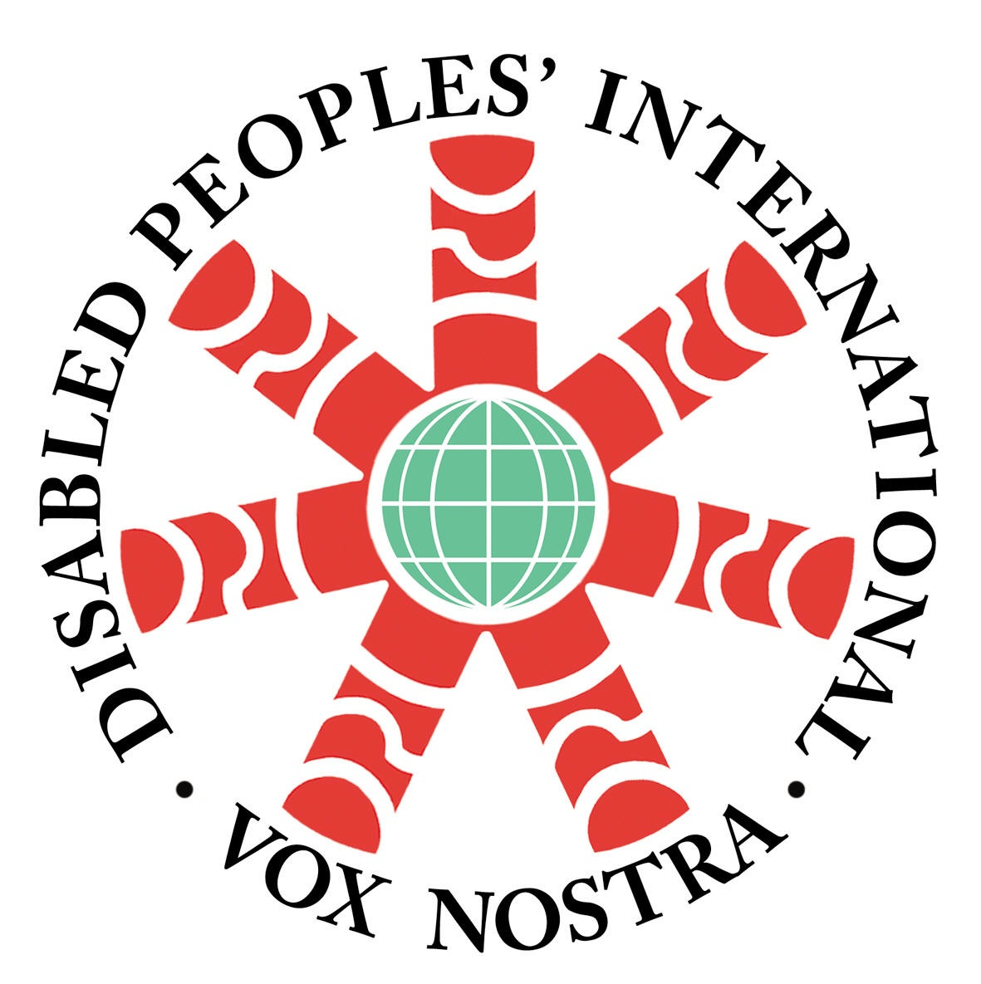

VOICE OF DISABLED PEOPLE INTERNATIONAL.
Registration No: 14730.
“Nothing about us without us”.

Mauritius Shadow Report on the UN Convention on the Rights of Persons with Disability

LOIPR session 26 July 2019

VDPI in Mauritius is a federation of NGOs representative of different types of disabilities namely visually impaired, hearing impaired, intellectually impaired and mobility impaired persons.
Our main goal is to fight for the rights of persons with disabilities and to represent their voice through lobbying and advocacy with the government private entities and the civil society at large. The present submission was drafted in consultation with VDPI members.

The objective of the submission is to provide responses in regards to the last shadow report submitted by the then federation of DPOs and the adverse report Mauritius got from the committee panel in 2015 for the implementation of the UN Convention on the Rights of Persons with Disabilities (CRPD) in Mauritius.
At the outset we would like to highlight the fact that the State party did not involve civil society organizations, in particular organizations of persons with disabilities, in the preparation of its periodic report.
We have to also underline that the State party did not disseminate the concluding observations from the committee panel in 2015 widely, including to non-governmental organizations and representative organizations of persons with disabilities, as well as to persons with disabilities themselves and members of their families, in national and minority languages, including sign language, and in accessible formats, and to make them available on the government website on human rights.
The State party has not shown any inclination (in accordance with article 35, paragraph 2, of the Convention), to provide information on the measures taken to implement the Committee’s recommendation as set out above in paragraph 8 and 42, which concerns the withdrawal of the State party’s reservations, the ratification of the Optional Protocol to the Convention and the Marrakesh Treaty.

The basis of the Convention is nondiscrimination .As at now there has been no change/amendments brought to the Constitution of Mauritius so as to remove discrimination against PWDs.

* VOICE OF DISABLED PEOPLE INTERNATIONAL.
Registration No: 14730. “Nothing about us without us”.
1 Women with Disabilities(WWD)  2.La Fraternité Mauricienne des Malades et Handicapés(FMMH)  3.Dis Moi  4.Muscular Dystrophy Association(MDA)  5.Autisme Maurice  6.Society for the Welfare of the Deaf(SWDeaf)  7.Association des Parents d'Enfants Infimes Moteurs(APEIM) | 8.Association pour la Rehabilitation des Informes moteurs(APRIM)  9.Association des Parents Deficience Auditifs(APDA)  10..Mauritius Mental Health Association(MMHA)  11.Green Life  12.Eastern Welfare Association for the Disabled(EWAD)  13. Inclusion Maurice(Represents 12 NGOs)
Table of contents

- Introduction
What is Voice of DPI of Mauritius? 3
Field of Activities
Methodology of the Report
General Principles and obligations (arts. 1- 4)
Assessment Procedure

B. Specific rights (arts. 5-30) 7

Equality and non-discrimination (art. 5)
Women with disabilities (art. 6)
Children with disabilities (art. 7)
Awareness-raising (art. 8) 8
Accessibility (art. 9)
Situations of risk and humanitarian emergencies (art. 11)
Equal recognition before the law (art. 12)
Access to justice (art. 13)
Liberty and security of the person (art. 14) 9
Freedom from Torture or cruel, inhuman or degrading treatment or punishment (art. 15)
Freedom from exploitation, violence and abuse (art. 16)
Protecting the integrity of the person (art. 17)
Living independently and being included in the community (art. 19)
Respect for Privacy (art. 22)
Education (art. 24) 11
Health, habilitation and rehabilitation (arts. 25 and 26) 12
Work and employment (art. 27) 13
Participation in political and public life (art. 29) 13
Participation in cultural life, recreation, leisure and sport (art. 30)
C. Specific Obligations (arts. 31-33) 12
Statistics and data collection (art. 31)
International cooperation programming and i (art. 32) 13
National implementation and monitoring (art. 33) and (art 34)

Annex 1 (a) & (b) 14
Annex 2 16
Annex 3 (a) & (b) 20

A. Introduction
What is Voice of DPI of Mauritius?
- Voice of DPI (Mauritius) is a federation of Disabled Person Organizations (DPO). It is an alliance of 10 DPOs which also comprises another federation namely Inclusion Maurice which represents 12 NGOs with cross disability representation. The DPO’s affiliation with Voice of DPI Mauritius is conditional upon strong disability representation and their engagement with advocacy work. We accordingly represent Persons of all types of impairment as enshrined in the convention. VDPI Mauritius is also affiliated with Disabled People International.
Field of Activities
- Our fields of activities include but are not limited to the following:
- Vigorous and regular campaign for the rights of persons with disabilities to be respected protected and promoted.
- To combat the charitable model of disability in all its form.
- Work with other Civil Society Organization with the common goal of building up a full inclusive society.
- Fight for equality and non-discrimination.
- Alert Public opinion by way of awareness campaign to oppose policies and practices which are violative of the rights of persons with disabilities.
- Above all, promote the human rights model of disability in line with the Convention.

Methodology of the Report
- A first draft was prepared by the executive committee members of VDPI Mauritius. Same was circulated to all our affiliated DPO’s and other Civil Society Organizations. They were given one month to submit their views and comments. The services of an Independent consultant were then hired to prepare the final draft. This report reflects the daily experience of persons with disabilities living in Mauritius, Rodrigues and Agalega. It also takes into consideration the daily experience faced by individual persons with disabilities with whom we are in direct contact. It should also be underlined that the government has completely disengaged itself with the present exercise and has not allocated any resources be it financial or otherwise to support this initiative.

- In 2015, the UNCRPD Committee issued its first country report.
The report was never disseminated in consultation with DPO’S and Civil Society Organizations as was recommended by the committee at paragraph 48, 49 (CRPD/C/MUS/CO/1).
The government has not taken any initiative to implement the concluding observation and recommendation. Consequently, no policies or legislative measures have been put in place.
By contrast VDPI, with its affiliated member’s organization have been very active in lobbying government ministries. Our main areas of activities on the ground include, inter alia;
1) Campaign for the right to inclusive education.
2) Training opportunities.
3) Employment Services.
There are valid and good justifications for VDPI Mauritius to believe that persons with disabilities are worse off today than in 2015.
This shadow Report analyses the different provision of the Convention and explains in detail in an objective manner the reality faced by persons with disabilities.
General Principles and obligations (arts. 1- 4)
Assessment Procedure
5) The assessment of disabilities for the purpose of allocating disability benefits is still purely and simply medicalized. All person must be certified of being 60 percent disabled in order to qualify for what is still called ‘basic invalidity pension’. The medical examinations are carried by general medical practitioners who are not necessarily versed with specific types of impairment. The criteria for eligibility are ill-defined, vague and arbitrarily applied. Over and above, Basic Invalidity pensions, persons who are ‘severely disabled’ are entitled to carer’s allowance. However, it is still unclear as to who is eligible to benefit from this carer’s allowance. There are no defined criteria for disability assessment in Mauritian law.
6) Despite recommendations to amend the Equal Opportunity Act (EOA) and the Training and Employment of Disable Person’s Act (TEDP act) by the UNCRPD Committee due to their incompatibility with the Convention, the government has simply ignored these recommendations. Although the TEDP Act stipulates that suitable accommodation should be provided upon employment of PWDs, the EOA stipulates that employers may not employ PWDs if suitable accommodation is a burden on their finance. By contrast the Training and Employment of disabled board has been dysfunctional and has not been able to provide training services which are in line with the demand of the labour market.
7) The National Strategy Paper and Action Plan 2007 – 2015 has not been updated and there is no forum for persons with disabilities to be consulted through their representative organization on policies and legislative measures which affect their daily living condition.
8) At paragraph 4 of its initial country report (CRPD/C/MUS/CO/1), the UNCRPD Committee commended Mauritius in:
- Country Report: The Employment Rights Act of 2008, which specifically prohibits harassment on the basis of disability at work (CRPD/C/MUS/CO/1, para. 4a)
Comment: VDPI Mauritius reiterates that there has been no awareness raising as to where and how complaints should be registered. At any rate, up to date there is no data on the number of complaints so far registered.
- Country Report: The launch of a database on disability in 2012 (CRPD/C/MUS/CO/1, para. 4b)
Comment: Up to date the database is still not operational (project funded by the UNITED Nation Development Program)
- Country Report: The substantial increase of the social budget in support of persons with disabilities (CRPD/C/MUS/CO/1, para. 4c)
Comment: The social budget was further increased to extend basic invalidity pension to children with disabilities from 0 to 15 in 2016 budget. However, as mentioned above the criteria of eligibility are still ill defined and vague.
- Country Report: The establishment of a national monitoring and implementation committee on persons with disabilities under the Ministry of Social Security (CRPD/C/MUS/CO/1, para. 4d)
Comment: The monitoring and implementation committee provided for by the National Action Plan 2007- 2015 has not met at all since 2015. It will be recalled that it was intended to be chaired by the Honorable Minister of Social Security.
9) The state of Mauritius has violated its commitments:
- Has not ratified the optional protocol to the UNCRPD.
- Has not ratified the Marrakesh Treaty.
- Has not withdrawn its reservations on articles 9, 11 and 24 of the Convention.

10) The state of Mauritius does not recognize denial of ‘’reasonable accommodation’’ as a form of discrimination and nor does the law provide for any sanction for non-compliance.
B. Specific rights (arts. 5-30)
Equality and non-discrimination (art. 5)
11) The State of Mauritius:
a) has not amended Section 16 of the Constitution to provide for the explicit principle of non-discrimination against persons with disabilities. As such disability discrimination is still non-justiciable.
b) has not reviewed all its legislations and brought them in line with the Convention.
c) Despite strong lobby from DPO’s and Civil Society, the government has not introduced the
d) Disability Bill in the National Assembly. Annex 1(a and b)
Women with disabilities (art. 6)
12) In its 2018 Report, the UN Committee on the Elimination of all Forms of Discrimination against Women (CEDAW/C/MUS/CO/8, para. 11) clearly demonstrated that women with disabilities are a disadvantaged class and as such are exposed to intersectional and multiple forms of discrimination. Since the issue of the last UNCRPD report concluding observations, the government has failed to:
- Address the issue of gender in balance in relation to women and girls with disabilities.
- Has not introduced any legislative measures to protect women and girls with disabilities from domestic violence both within and outside the home. Annex 2
13) Subsequent to the issue of General Comment number 3 on article 6 (CRPD/C/GC/3) of the Convention, the Federation of women with disabilities called for a dissemination of the same in order to formulate policies and legislative measures to combat discrimination experienced by women and girls with disabilities. However, the Ministry of Gender Equality and Child Development refused to embark on such an important path.
Children with disabilities (art. 7)
14) In its last report, the UNCRPD endorsed the Committee on the Rights of Child (CRC) findings (CRC/C/MUS/CO/3-5, para. 49). The CRC concluded that there is an undue and disproportionate reliance upon NGO’s to dispense segregating education services to children with disabilities. The system does not provide for an effective monitoring of quality education services as a result of which most of these NGO’s are running day care centers as opposed to decent inclusive educational set up. To add insult to injury in 2018 the government has set up Special Education Needs (SEN) with a view to further support NGO’s.
Awareness-raising (art. 8)
15) As per Action Plan 2007 to 2015 the then government embarked on a vigorous awareness raising campaign entitled Valuing Persons with Disabilities. However, since 2015 there is no itemized budget for awareness-raising.
Accessibility (art. 9)
16) Despite the recommendation on accessibility, no legislative and policy measures have been introduced. The government is massively investing in what is term Metro Express as a new mode of transport. However, there have been no consultations with persons with disabilities through representative organization. It is clear from the designed plans that persons with disabilities shall not be able to access this new mode of transport due to become operation as from September 2019. Annex 3 a & b
Situations of risk and humanitarian emergencies (art. 11)
17) The National Risk Reduction and Disaster Management ACT is not in line with article 11 of the Convention in as much as persons with disabilities through their representative are not actively engaged in its implementation. There is no accessible policy to evacuate persons with disabilities in situation of risks or of personnel of the Fire Service Force or Police Force is not trained to do so. Moreover, there is no data on the number of persons of disabilities who might need assistance during or after natural calamities.
Equal recognition before the law (art. 12)
18) No legislation has been introduced in line with article 12 of the convention and its general comment number 1 (CRPD/C/GC/1/Corr.1) to replace substituted decision making by supported decision making regime. As such the legal capacity of persons with disability to enter into insurance contracts, to hold bank account, to marry, to vote are still within the purview of archaic guardianship laws under the civil code.
Access to justice (art. 13)
19) Since ratification of the UNCRPD, no single effort has been made for the implementation of Article 13 in as much as:
- The concepts of ‘’procedural accommodation’’ and ‘’age appropriate accommodation’’ as enshrined in Article 13 have not been domesticated in our legislation and policies.
- None of our courts are physically accessible and/or provisions made to cater for sign language, braille or other alternative accessible mode of communication.
- Legal and paralegal professionals including judges, magistrates, prison officers, court ushers have never received any training on the implementation of Article 13.
- Persons with Disabilities are not themselves educated on how they can be direct or indirect participants in our justice system.
- The government is massively investing in a new Supreme Court. However, despite request from DPO’s to assist actively in the implementation of the project our voices have remained unheard.
Liberty and security of the person (art. 14)
20) Under the Mental Health Act persons with disabilities, in particular persons with psychosocial and intellectual disabilities, are involuntarily detained. The Act even empowers the medical board to incarcerate persons with disabilities without the right to legal representation or a right to appeal against such decision.
Under the Community Service order Act, in case parents declares to the police that a child is ‘’beyond control’’ the Magistrate have the power to immediately commit the child to RYC or CYC. Again the child has no right to Legal Representation. Children’s with disabilities liberty and security are accordingly compromised.
21) Recalling the recommendations of the HRC on article 2 (CRPD/C/MUS/CO/1, para. 6) we invite the committee’s attention to the following:
1. Mauritius has not yet introduced the Police and Criminal Evidence Act to the assembly.
2. No training has so far been dispensed to police officers as to how to properly address persons with disabilities, in particular persons with psychosocial and intellectual disabilities in the course of the enquiries.
3. It is reported that during pretrial procedures persons with disabilities do make confessions due to unfair means exerted by police officers.
Freedom from Torture or cruel, inhuman or degrading treatment or punishment (art. 15)
22) No research has been carried out so far on the extent to which persons with disabilities are subject to torture by police or prisons officer and/or their condition of detention. This conclusion has been reached after asking the question to representative of the national human rights commission and cross checked with DPO’S and civil society organizations and is able to confirm that no research has been carried out.
Freedom from exploitation, violence and abuse (art. 16)

Protecting the integrity of the person (art. 17)
23) The recommendation of the initial UNCRPD report (see CRPD/C/MUS/CO/1, para. 28) has so far not been implemented. There is no disseminated data on the number of persons with disabilities who are subject to exploitation, violence and abuse who are living in homes and shelters. These persons are not even able to access the Criminal Justice System or claim damages. Boys and girls with disabilities in institutions are particularly exposed to sexual violence and abuse.
In Relation to articles 16 and 17, women and girls with disabilities both inside and outside institutional sets up are still subject to forced sterilization and abortion without any mechanism for redress before our Justice System.
Living independently and being included in the community (art. 19)
24) Subsequent to General Comment number 5 on article 19 (CRPD/C/GC/5), Civil society and VDPO’S strongly lobbied for the state to organize a dissemination session for all stakeholders in the sector. Our appeal has so far remained unheard. The concept of independent living and inclusion in the community is neither understood nor implemented. By contrast, there is both private and public sector investment in day care centres and homes.
Personal Mobility (art 20)
Freedom of expression and opinion, and access to information (art. 21)
25) While Freedom of Expression is recognized by Article 11 of the Constitution of Mauritius, no steps have so far been taken for sign language to be recognized as an official language.
Other formats such as Braille easy to read are available only in specialized NGOs. Subtitles in films are at source and no local programs are subtitled on National TV channels.
Respect for Privacy (art. 22)
26) No specific legislation or policies are in place to protect the specific needs of persons with disabilities privacy.
Respect for home and the family (art.23)
Education (art. 24)
27) The National Action plan 2006 on inclusive education is not only completely outdated but has never been implemented. Despite requests by civil society to carry out research on the Socio Economic and cultural Benefit of inclusive Education the State has still not done so. There is no curricular adaption and adjustment by any institution to kick off any program of inclusive education.
28) There is still a confusion between the concept of Integrated and inclusive education and nor has the government moved away from integrated to inclusive education. It is unclear as to what percentage of children are completely excluded from school due to inaccessible transportation and buildings being inaccessible.
Health, habilitation and rehabilitation (arts. 25 and 26)
29) The National Health Service in Mauritius is free but remains largely inaccessible to people with disabilities due to lack of training to medical and paramedical personnel. There is no data on the number of patients with disabilities who cannot simply access services on an equal basis with others.
30) There is no community-based rehabilitation although there is a Community Based Rehabilitation Unit which falls under the Ministry of Health and Quality Of Life. There is evidence to suggest that women with disabilities are exposed to aggravated form of discrimination in accessing gynecological public services.
Work and employment (art. 27)
31) The Recommendations of the UNCRPD on Article 27 (see CRPD/C/MUS/CO/1, para. 37) have been completely ignored and the Training and Employment of Disabled Person Act is completely dysfunctional in as much as: Please provide information on the
1) It has not even recruited trained personnel including a general manager to coordinate its services.
2) It has only been assessing the ability and/or suitability of persons to be placed in employment and the assessment procedures are highly medicalized.
3) There is either no training or the training provided are not in line with the demand of the labor market. As a consequence, the number of persons with disabilities employed in the labor market has substantially decreased.
4) At any rate there is no data collection.
32) In Mauritius, there is a Universal Basic Elderly Pension that anyone reaching the age of 60 is legally entitled to. However, persons with disabilities who benefit from basic invalidity pension becomes ineligible to the disability benefit same upon reaching the age of 60. The state takes the view that they are only an elderly person without a disability.
Adequate standard of living and social protection-(art. 28)
Participation in political and public life (art. 29)
33) The discriminatory provision enshrined in constitution has so far not been repealed and replaced by provisions which are in line with article 29 of the convention.
34) It is unclear as to what percentages of persons are simply unable to cast a vote for numerous reasons:
1) Election information being inaccessible.
2) Physical inaccessibility of polling station.
3) Bulletin papers not being in an accessible format.
4) There is no data on the number of persons who actively participate in public administration including the Civil Service or are able to participate in decisions which affect their daily living condition.
Participation in cultural life, recreation, leisure and sport (art. 30)
35) While Mauritius is a touristic destination none of the leisure site is accessible.
C. Specific Obligations (arts. 31-33)
Statistics and data collection (art. 31)
36) As mentioned above, (para. 29) the database initially intended to collect data on areas covered by the convention in line with the Washington Group Methodology is still not yet implemented.
International cooperation programming and i (art. 32)
37) International Development programs are not inclusive of and accessible to persons with disabilities or their representative organization. PWDs or their representative organisations are not consulted in the programming and implementation of these programs. There is absolutely no policy to include participation of PWDs.
National implementation and monitoring (art. 33) and (art 34)
38) As of today, no focal point has been designated with the required disabilities representation and with adequate financial support. As mentioned above, the monitoring committee intended to be chaired by the Honorable Minister of Social Security has not met at all.
The composition of the Committee is supposed to be multi-sectoral and comprised of representatives of different Ministries, Departments, Attorney General’s Office, the Private Sector, NGOS, DPOS, local branches of International Disability Organizations and Disability Activists to promote collaboration as well as monitoring and representation of the voice of a range of stakeholders. Government is regularly apprised, through the Cabinet, of the work of the Committee and progress regarding the implementation of CRPD.
The work of the Committee is to be carried out through several sub-committees such as- Education, Accessibility, Human Rights, Awareness, Training and Employment and Sports, Culture and Leisure. These committees must be represented by different government and non-governmental stakeholders with expertise in the concerned area, promoting networking, collaboration and monitoring.
The Government of Mauritius was supposed to set up since 2012 a Human Rights Monitoring Committee which would be located at the Prime Minister’s Office, composed of representatives of Government and other stakeholders, for the monitoring and evaluation of measures taken.
39) There is no independent mechanism in line with the Paris Principles to monitor the implementation of the convention.

